CENWP-OD-B 18 June 2023

MEMORANDUM FOR THE RECORD

SUBJECT: 23BON030 MFR BI LPS RB3 Pacific Lamprey Mortality

On 18 June, Bonneville Fisheries discovered one Pacific Lamprey mortality in rest box 3 of the Bradford Island Lamprey Passage System The fish was scanned for PIT tags, inspected, and returned to the river.

- Species – Pacific Lamprey (Entosphenus tridentatus)
- Origin – Unknown
- Length – 63.5 cm
- Marks and tags – None
- Marks and Injuries found on carcass – None
- Cause and Time of Death – Unknown
- Future and Preventative Measures – None
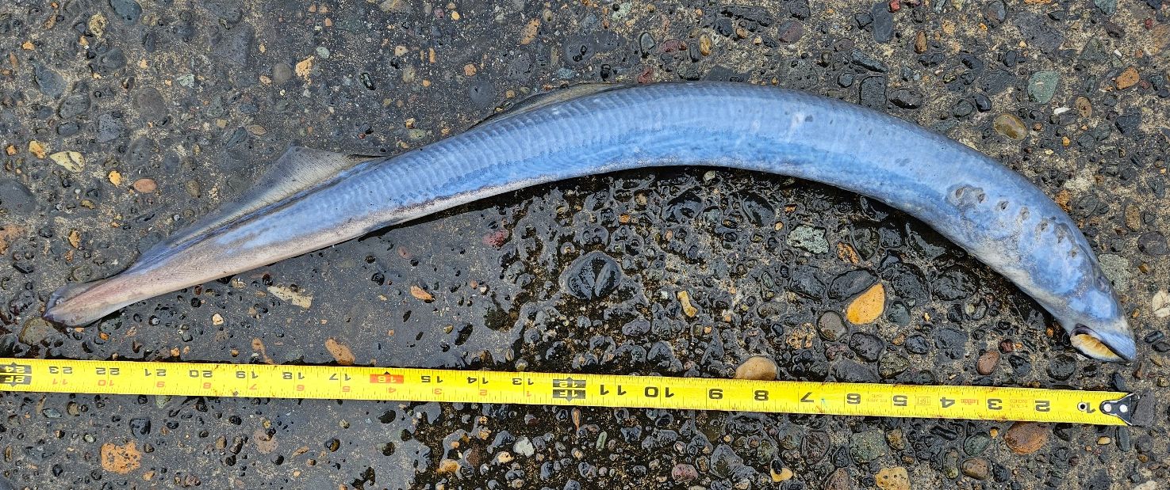

Sincerely,
Bonneville Project Fisheries

